CHALLENGING EXPERIMENT 8

15BCE0517

M.S.SANJAY

1) H0: mu=3

H1:mu~=3

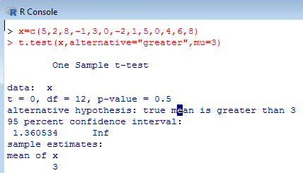

Conclusion: As p-value(0.5) is greater than 0.05, we accept the null hypothesis H0 that we conclude that in general stimulus can be accompanied by increase in blood pressure.

2) H0: mu=25

H1: mu~=25

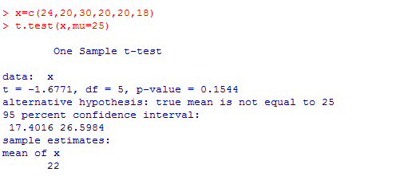

Conclusion: As p-value(0.1544) is greater than 0.01, we accept the null hypothesis H0 that we regard the producer's claim.

3)

H0: mu=4000

H1: mu~=4000

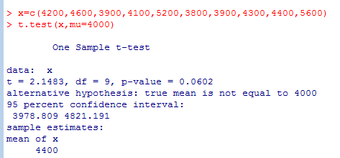

Conclusion: As p-value(0.0602) is greater than 0.05, we accept the null hypothesis H0 that the average life time of bulb is 4000 hrs.

4 & 5)

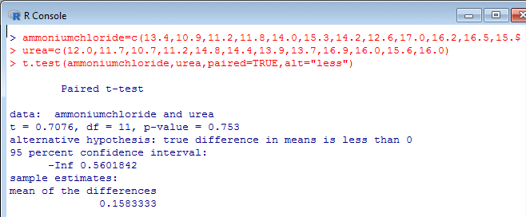

Conclusion: the p-value(0.753) is greater than the level of significance (0.05). so we do not reject our null hypothesis. hence the ammonium chloride is the better nitrogen source for paddy.